Name : LOKESH J Course : Software Engineering
Reg No : 192311216
Experiment – 9

Question : Create a Scrum Project in Jira.
• Add a backlog with at least 5 items (e.g., "Create user
registration page", "Develop API for login").
• Prioritize the backlog and create a 1-week sprint.
• Move backlog items into the sprint and start the sprint.
• Finally show the Screenshot of the sprint board at the start and
end of the sprint.

Link :

Step 1: Open Jira
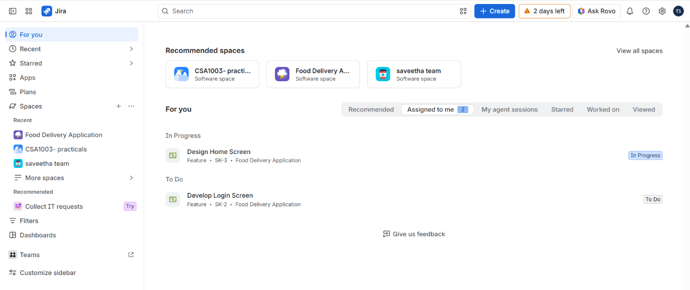

Figure : Home Page of Jira

Step 2: Create a Scrum Project
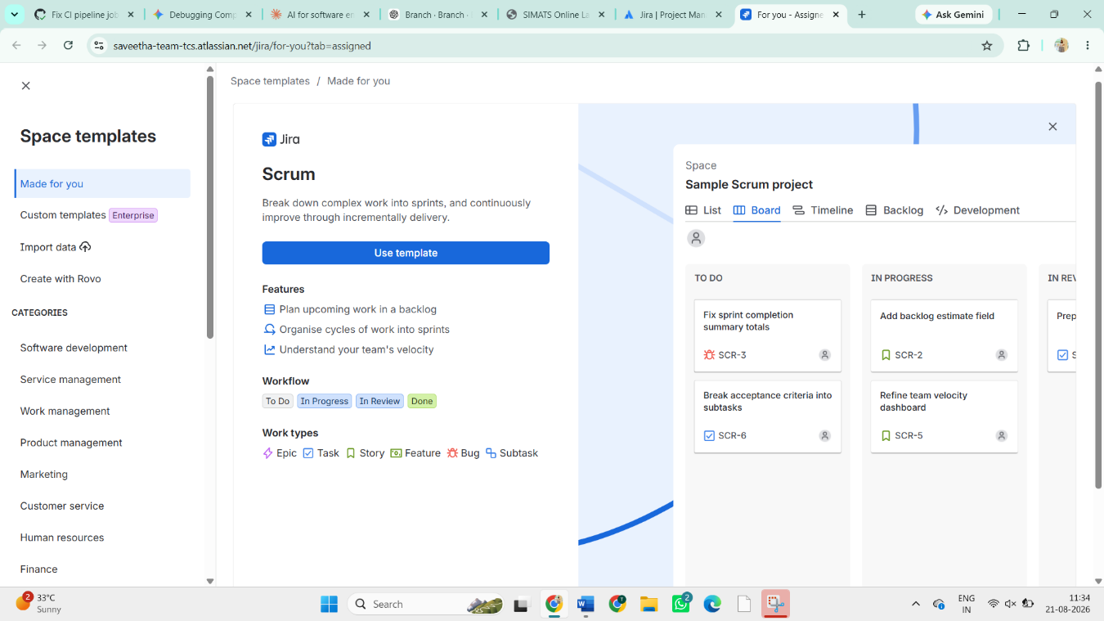

Go to spaces and click the Scrum template , and then follow up the instructions and create the Scrum.

Step 3: Create Backlog Items
- Enter a short description if required.
- Click Create for each item.
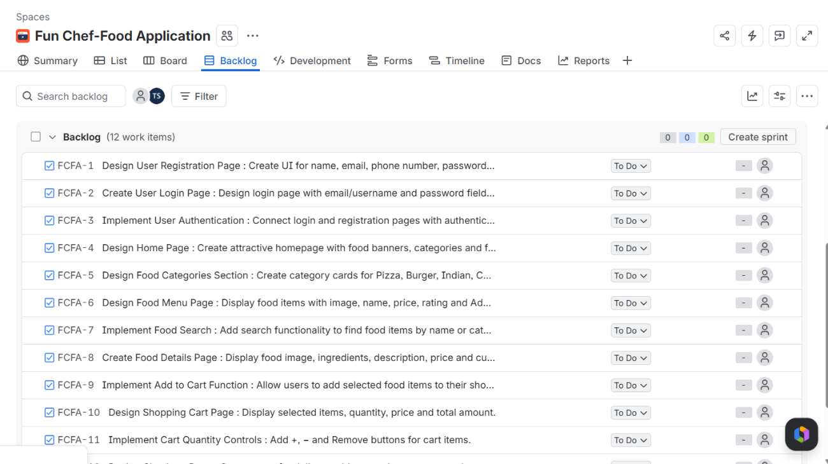

Step 4: Prioritize the Backlog
- Arrange the backlog items according to their importance.
- The most important item should be placed at the top of the backlog.
Step 5: Create a 1-Week Sprint
- Go to the Backlog page.
- Click Create sprint.
- A new sprint will appear.
- Rename it as: Sprint 1 – User & Shopping Features
- Set the sprint duration to 1 week.
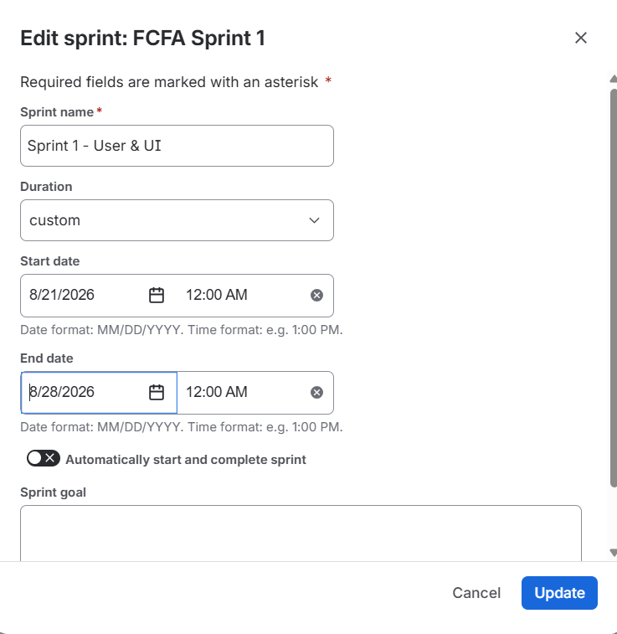

Step 6: Move Items into the Sprint
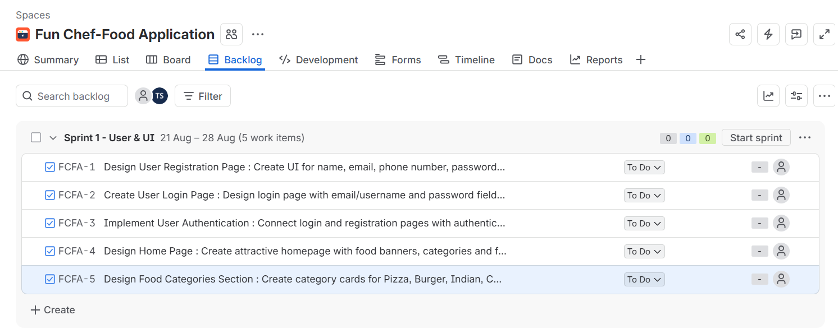

Step 7: Start the Sprint
- Click Start Sprint.
- Enter the sprint duration as 1 week if required.
The sprint board will now display the selected tasks.
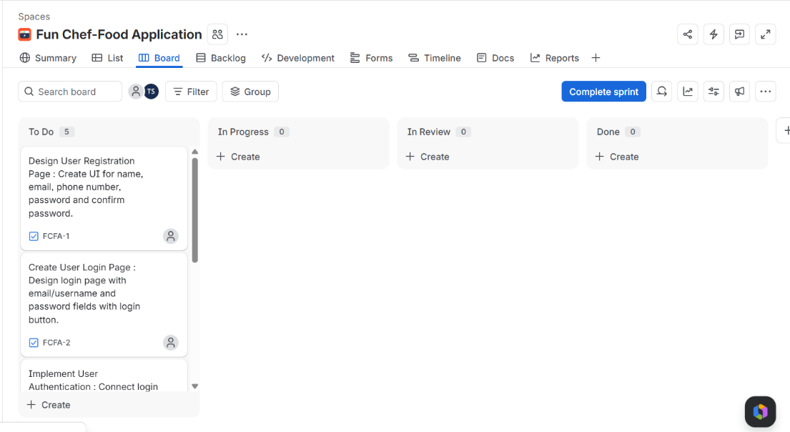

Figure : Start of a Sprint

Step 8: Update the Sprint Board
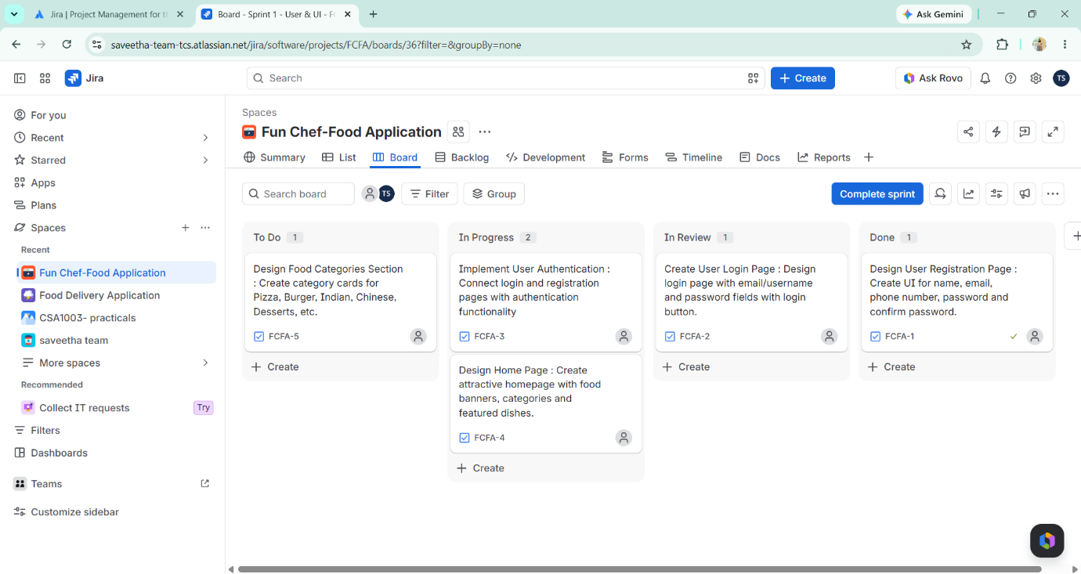

Figure : Updated Sprint

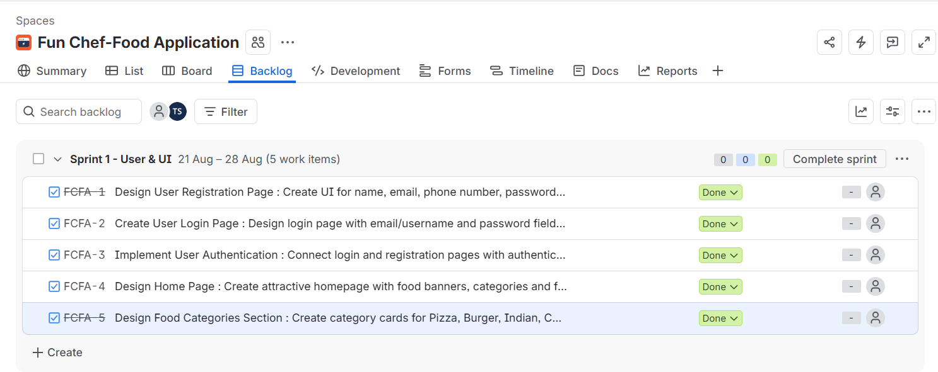

Figure : End of a Sprint

